Louis Maldonado Jr., Antonio Rossini, and Demilade Shoyombo

COSC 4485

February 20, 2018

Dr. Yuan

Lab 3

There are currently no known issues with this application.

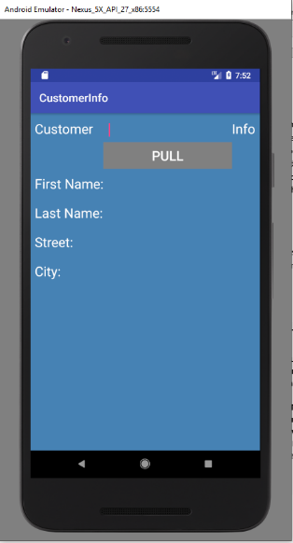This is what the application looks like when it is first opened. The pull button is visible but not enabled unless a proper entry has been made in the input box.

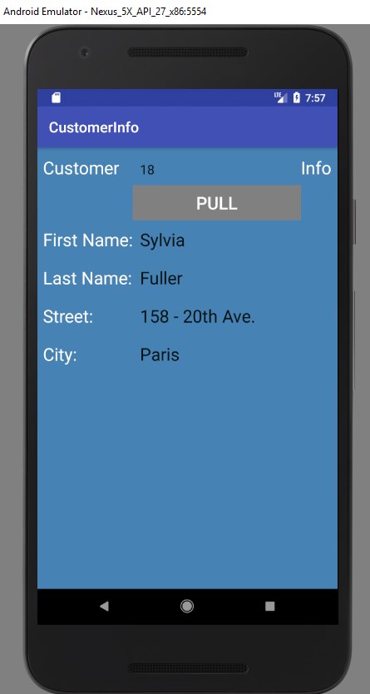 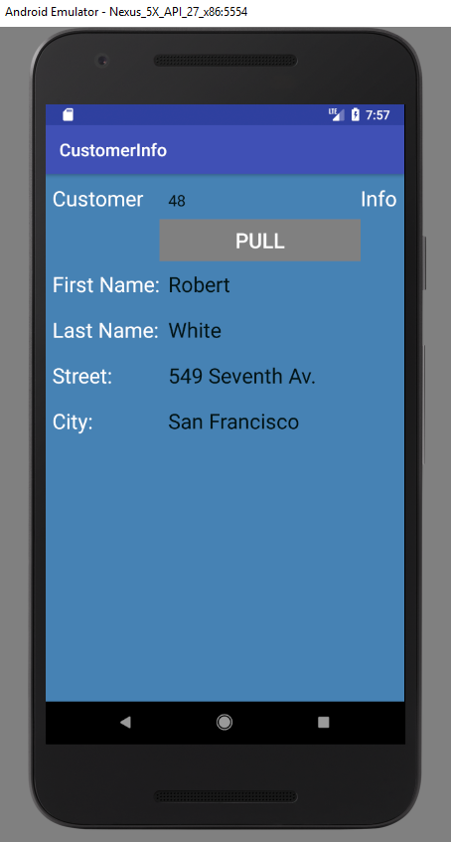The application will pull any customer data from the customer list.

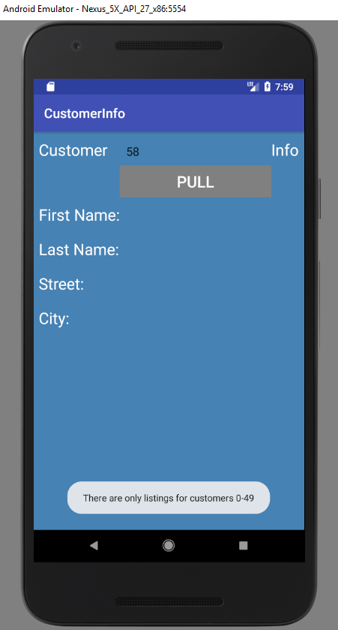 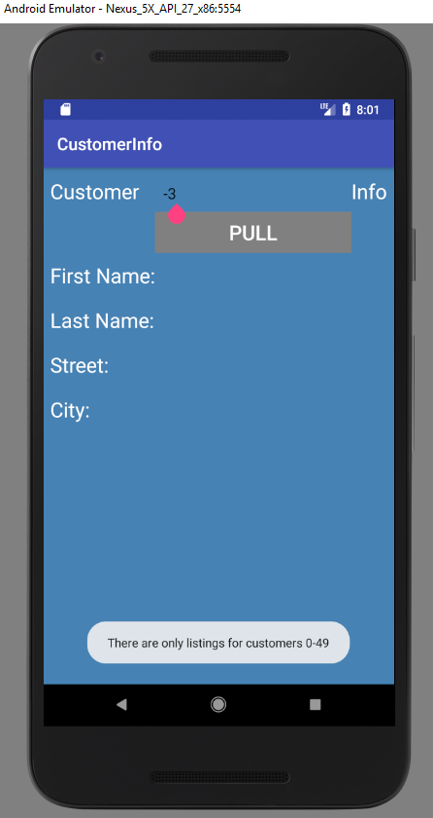There is only information for customers 0-49 so, the application will use a toast alert to let the user know this if they enter a number larger or smaller than the intended range.

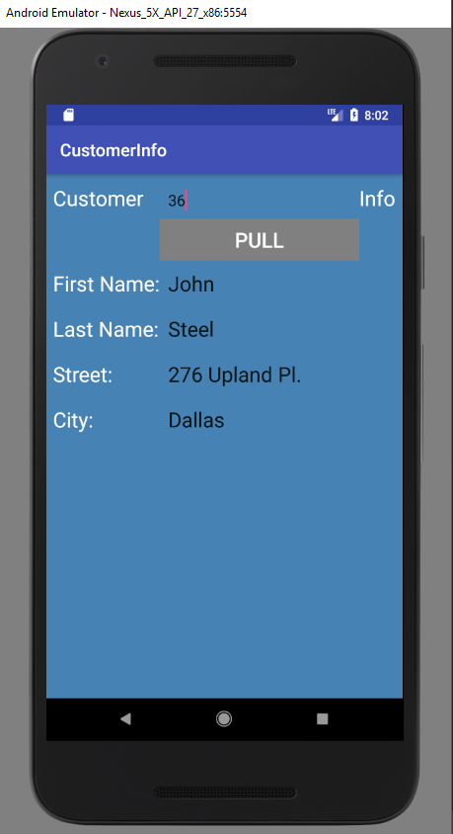 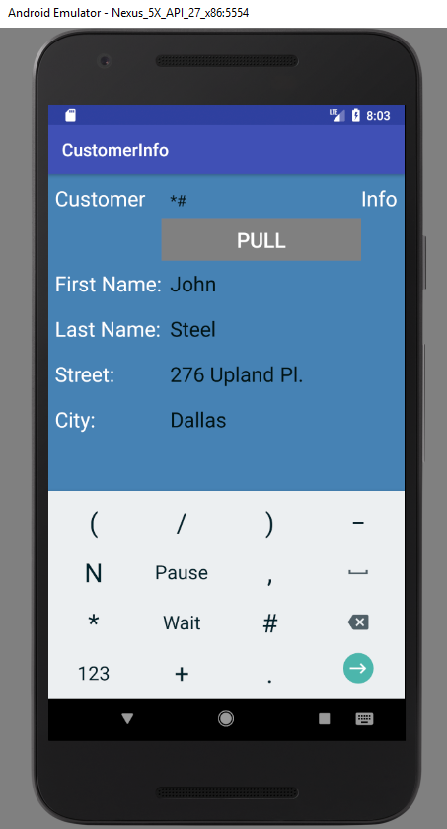 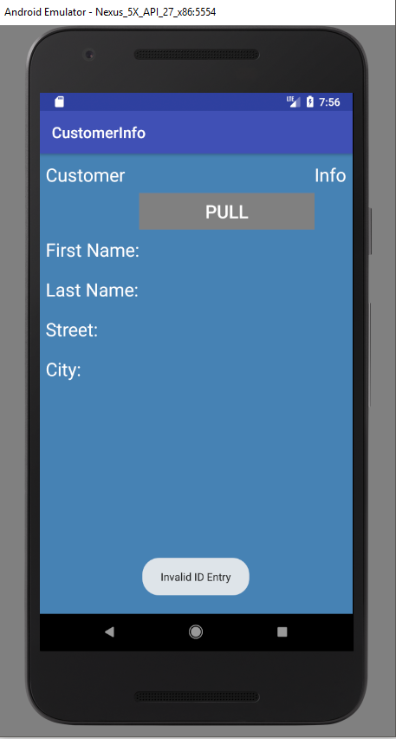When an invalid entry is made, the toast alert will appear and the screen will be cleared.